Aasish Tammana

CSE 571 – Artificial Intelligence

Homework 3

**Exercise 1.1**

a)

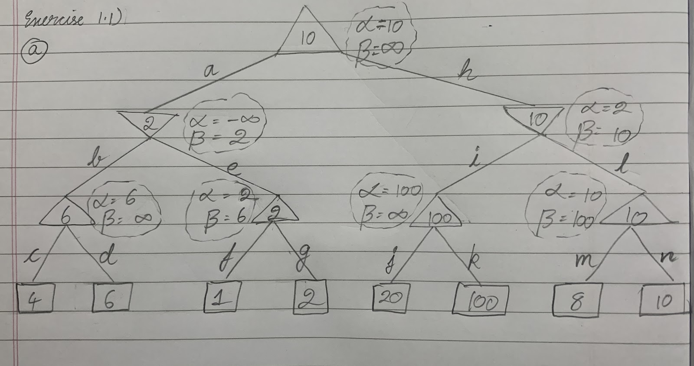

b)

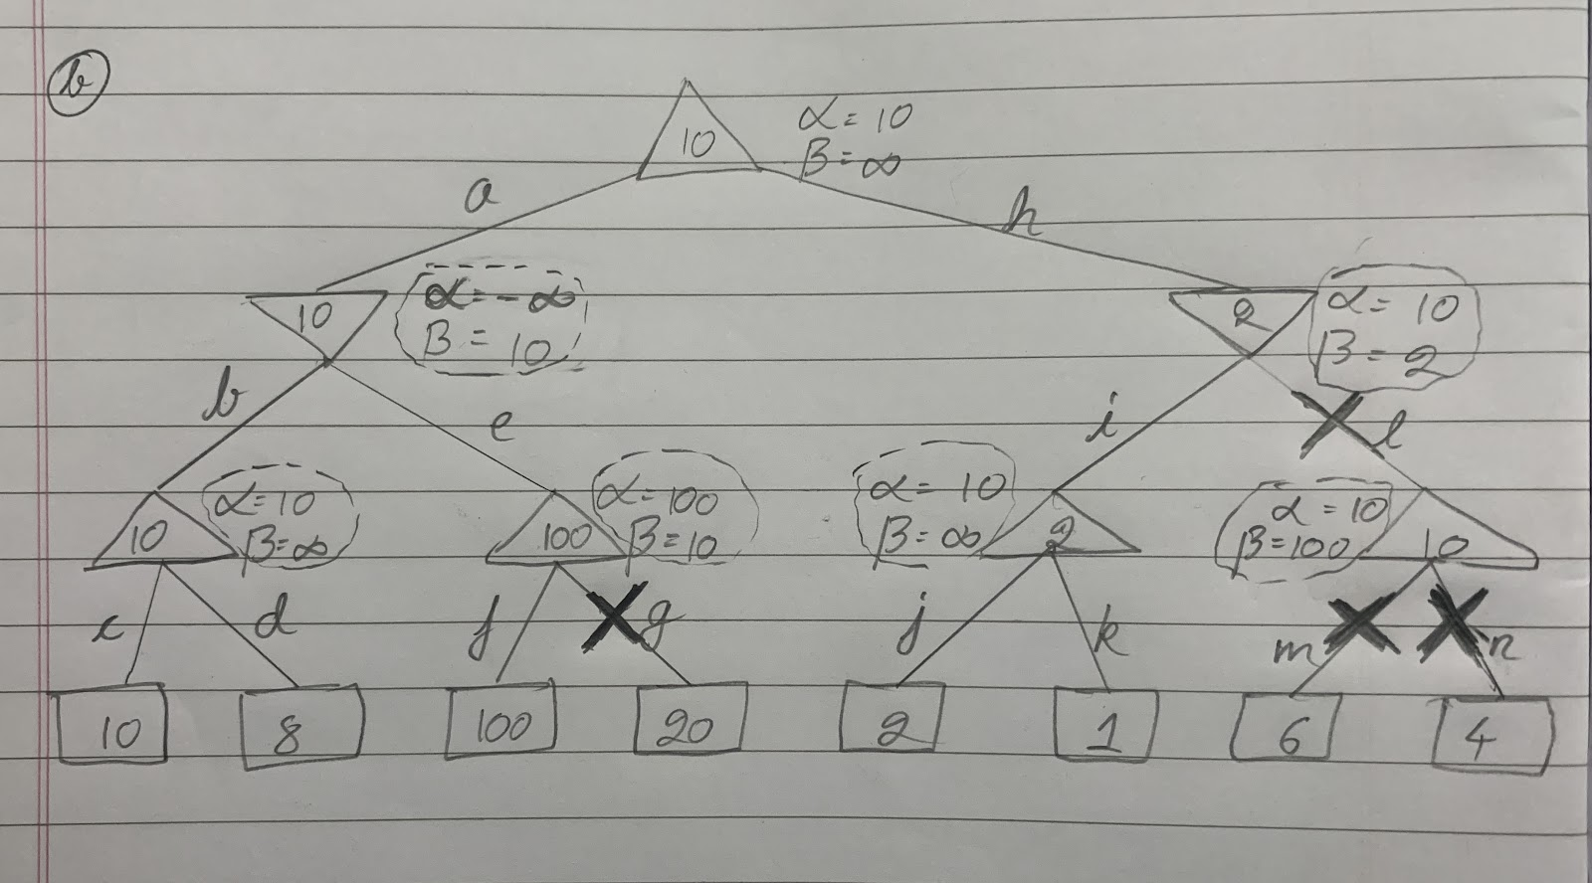

c) No, the leaf nodes at j and k will not be pruned because they belong to the left children of node h. Pruning occurs sequentially from left to right. The beta value will always be ∞ and this will not satisfy the condition of α≥β.

As seen in the below example, irrespective of what order the values are arranged pruning of these to leaf nodes will not occur.

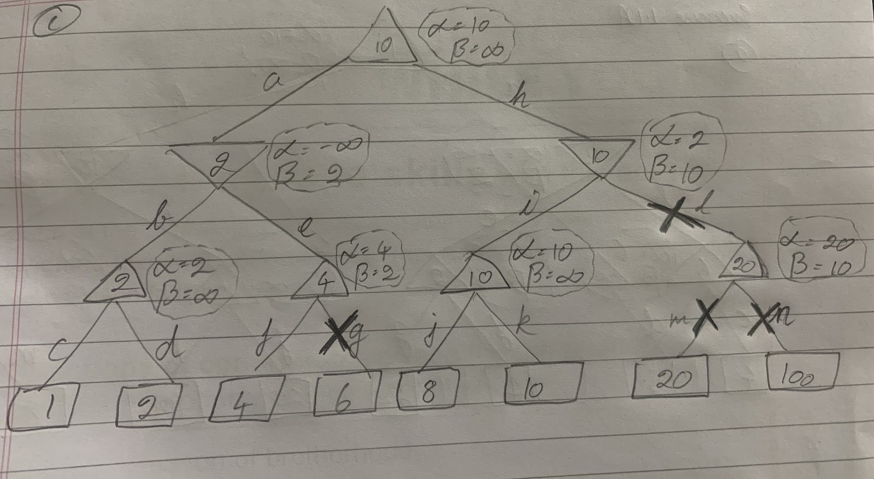

**Exercise 1.2**

a)

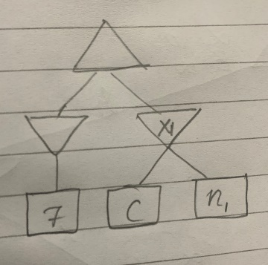

Considering the subtree shown above, it is evident that C must be greater than or equal to 8 i.e., greater than 7. Also, C must be less than 13.

To ensure that x1 and its leaves are not pruned, A and B are less than 11 and 13 but must be greater than 7

Hence, A≥7 or B≥7 and 8≥C≥12.

b) For X1 to be pruned, A≤7 and B ≤ 7. The value of C does not matter.

For n1 to be pruned, C will be ≤ 7 and A or B are greater than 7.

c) For the node n2 to be pruned, A and B can be anything greater than or equal to 0 and the value of C does not matter.

Therefore, A≥0 , B≥0 and C can be anything.

**Exercise 1.3**

1. No, pruning is not possible. As mentioned, since it is unbounded, there is always a chance that the further branches result in a higher value. Hence, we cannot prune and we will have to check the other leaves.
2. No, pruning is not possible. As stated previously, any leaf which is not visited might have a higher or lower value in comparison to the seen max node. Therefore, we must always calculate the expectation for all the nodes.
3. No, pruning is not possible. Just because the nodes are non-negative, doesn’t mean the previously highlighted issue in a) is resolved. There can always be a better outcome in the max tree through further nodes.
4. No, pruning is not possible. In this case also, highlighted issue in b) is not resolved. The non-negative values might result in lower bounds for the chance nodes but there can always be a better outcome in the expectimax tree through further nodes.
5. Yes, all values are set in the range [0,1]. This means if one of the starting leaves is 1, All the other nodes/leaves can be pruned since the parent and the root directly get the value 1.
6. Yes, in case of an expectimax tree, if all values are set in the range [0,1] then pruning is possible. As seen in the below example, the right most leaf can be pruned.

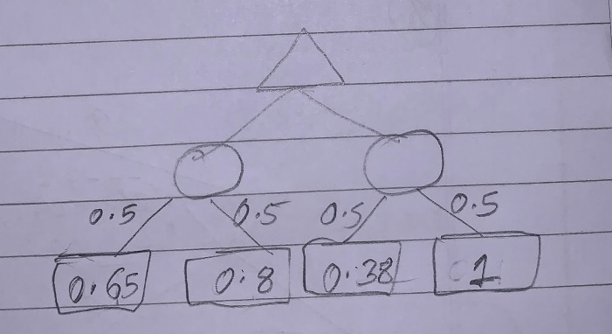

1. The highest probability first will likely yield more pruning opportunities because this results in strong bounds on the values of the nodes.

**Exercise 1.4**

1. True. As mentioned, the players are rational and environment is fully observable which means no other information is to be perceived. Therefore, the game is completely predictable because every player is going to be optimal. Hence, the opponents move doesn’t really impact the second players move i.e., after the first ones move.
2. False. As mentioned, the players are rational but the environment is only partially observable which means more information is to be perceived. The second players action can give the first player information apart from what is already known which could serve as a deciding factor for the next moves.
3. False. Even though, the pacman could be rational, the other agents, in this scenario, the ghost’s behaviour cannot be predicted. This means, pacman’s strategies may not give the best result and it might even end up losing. This is because pacman is a stochastic game.

**Exercise 1.5**

1. No, **without any restriction** on the values of the terminal nodes, we cannot expect any pruning opportunities on the expectiminimax tree as well. We know that the value of a chance node is computed by using the values and probabilities of all its children i.e. it is the weighted average. If we consider equal probabilities, it is the average of the children. Since we need to look at all the numbers to compute their average, we cannot prune them. However, if a bound is put up on the values of the leaves nodes, we will be able to achieve pruning without looking at all the nodes.
2. [Marked as a] in HW3 questions pdf]

Yes, there is a possibility of pruning since it is a deterministic min agent on the terminal values. This means, based on the terminal values the chance nodes can be computed without looking for all values. See below example for a pruning opportunity in expectiminimax tree as probabilities do not impact since it is a deterministic environment.

Assuming the values are bound to be in the range [0,9] we can see that, even if the final terminal node was 9(highest value) the node would have resulted in a value which is still lesser than 7.

The tree can be represented as follows.

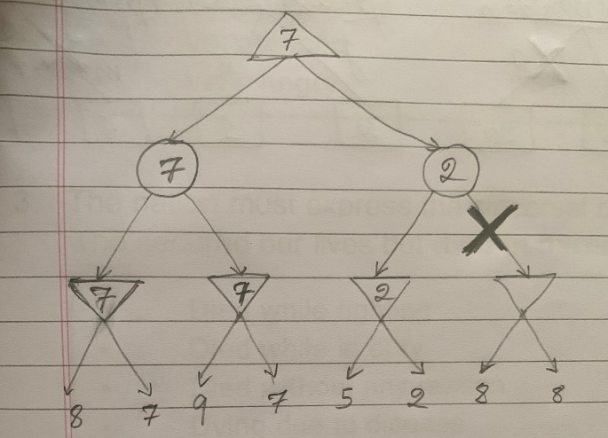

c) The minimax can be modified to represent expectiminimax as follows.

